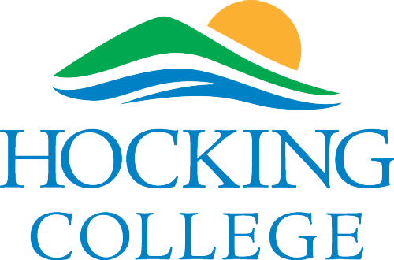

CAPTE ACCREDITATION ONSITE VISIT

The Physical Therapist Assistant Program at Hocking College will be hosting the upcoming onsite accreditation visit with the:

Commission on Accreditation in Physical Therapy Education (CAPTE)
3030 Potomac Ave., Suite 100, Alexandria, Virginia 2231
telephone: 703-706-3245
email: accreditation@apta.org
website: http://www.capteonline.org

If needing to contact the program/institution directly, please call 740-753-6350.

The CAPTE Accreditation visit will be hosted on the following dates and location:

June 23, 2024 – June 25, 2024
2nd Floor Davidson Hall

The Hocking College Physical Therapist Assistant Program is currently accredited until 12/31/24.

